# Showcase your work

Congratulations on earning your Google Data Analytics Certificate! Now it’s time to let the world know about the skills you gained to help advance your career. We recommend adding the completion of this certificate to your resume and LinkedIn profile. Read on and follow these tips to get started.

## Adding the Google Data Analytics Certificate to your resume and LinkedIn profile

You may have already started on a data analyst resume earlier in the certificate. If not, there are a variety of digital templates for creating your resume available at [Enhancv](https://app.enhancv.com/industry-examples), [Big Interview](https://googlecerts.biginterview.com/), [Google Docs](https://applieddigitalskills.withgoogle.com/c/middle-and-high-school/en/create-a-resume-in-google-docs/overview.html) or [Microsoft Word.](https://support.microsoft.com/en-us/office/use-a-template-to-create-a-resume-6053fbbb-94d8-471e-9957-49f4e7ab6fb8)

1. To add this certificate to your resume, we recommend first updating the *Education* section:



Education: google data analytics certificate, coursera 2021

associate of arts, KC community college, central, IL 2018

* To add the completion of this certificate to your LinkedIn profile, follow the [steps listed in this article](https://www.linkedin.com/help/linkedin/answer/381).

2. If applicable, update the *Skills* section of your resume. Below are some skills that this certificate was designed to help you develop that you could potentially add:

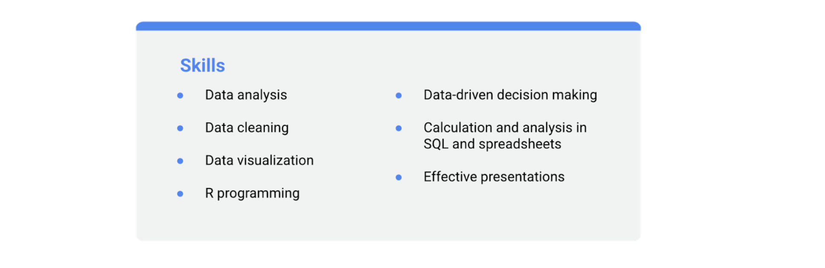

- data analysis

- data cleaning

- data visualization

- R programming

- data-driven decision making

- calculation and analysis in SQL and spreadsheets

- effective presentations

* To add or remove skills from your LinkedIn profile, follow the [steps listed in this article](https://www.linkedin.com/help/linkedin/answer/4976).

3. If you have a *Summary* section in your resume, you can include this certification as a qualification:

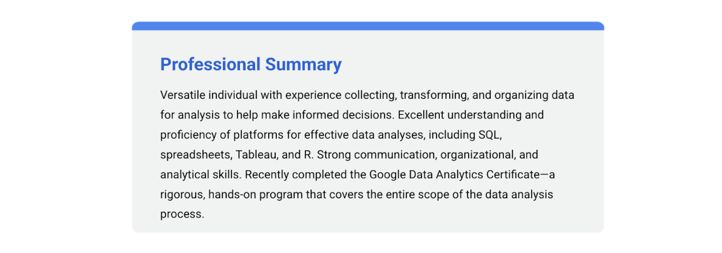

Versatile individual with experience collecting, transforming, and organizing data for analysis to help make informed decisions. Excellent understanding and proficiency of platforms for effective data analyses, including SQL, spreadsheets, Tableau, and R. Strong communication, organizational, and analytical skills. Recently completed the Google Data Analytics Certificate- a rigorous, hands-on program that covers the entire scope of the data analysis process.

4. Lastly, check out our upcoming course items to learn how to claim your course completion badge and add it to your LinkedIn profile!